**Day 4 – Assignment**

**Pratik K Kamble**

**Employee ID : 46263548**

**13 – 09 – 2022**

**Q1**: Write a program to get the firstname, lastname and year of birth as input and return the generated password. Follow the below table for more understanding.

|  |  |
| --- | --- |
| Class Name | StringUtil |
| Method | public String generatePassword(String firstName,String lastName, String yob): This should return the generated password. |
| Sample Input | PanKaj SHaRma 1983 |
| Output | ankhar83 |
| Note | User may give input in mixed case, your generated output must be in lowercase only |
| Class Name | StringUtilTest |
| Method | main(String[] args): For testing the StringUtil method |

**Solution –**

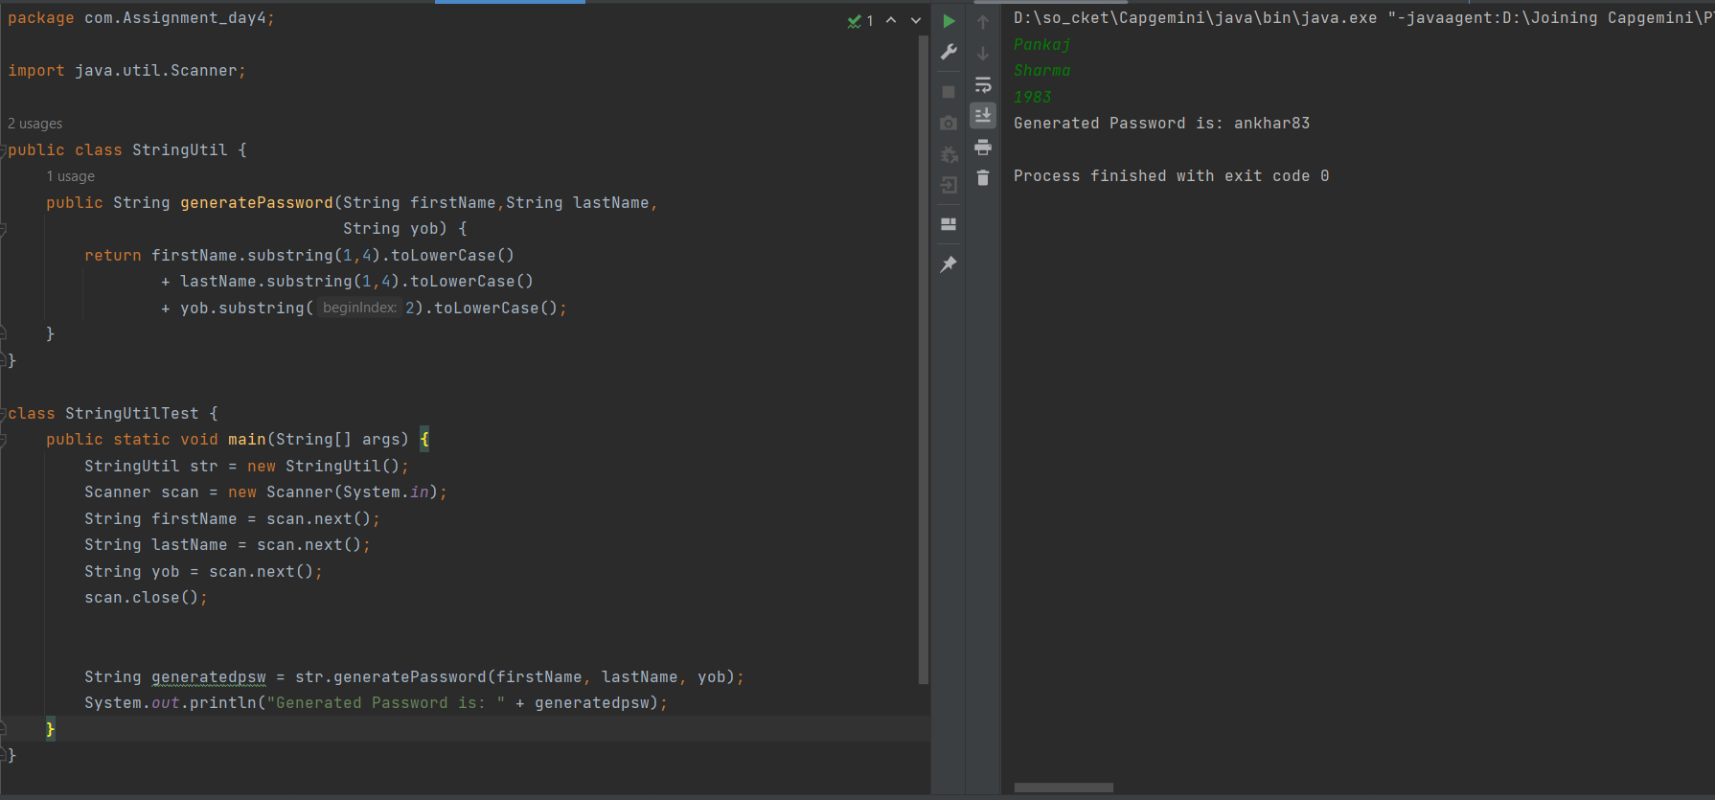

**Q2:** Create a method in the StringUtil class as, getCommand(). This method will receive on url and will return the command from this url. Follow below table for more understanding.

|  |  |
| --- | --- |
| Class Name | StringUtil |
| Method | public String getCommand(String url): This method will receive the url and return the command associated with that url. |
| Sample Input | www.sample.com/admin/createProject.html |
| Output | createProject |
| Note | Check with multiple and different type of urls |
| Class Name | StringUtilTest |
| Method | main(String[] args): For testing the StringUtil method |

**Solution –**

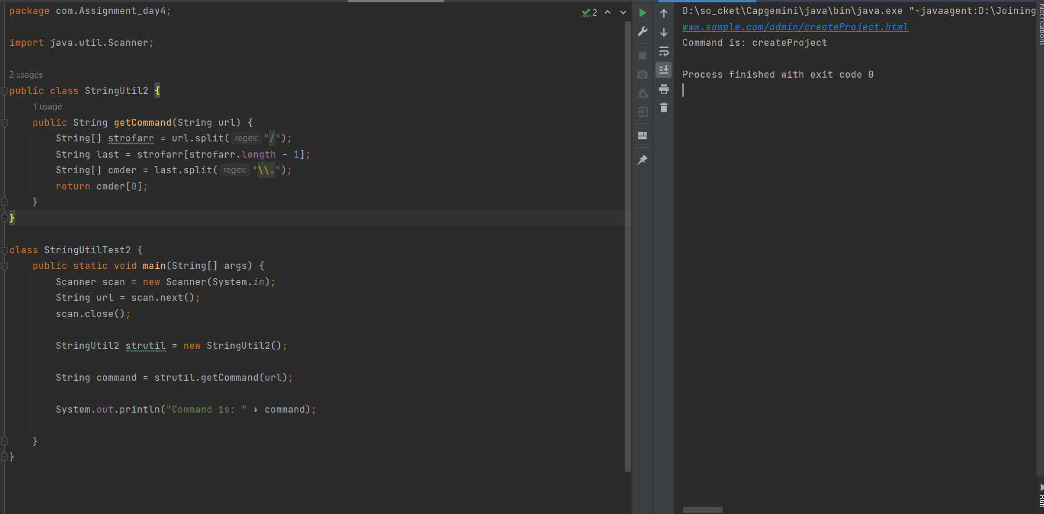

**Q3:** You need to work on the StringExercises class, that will have some set of static methods. You need to implement these methods as per the description. For testing different operations of the StringExercises class. Create a main class and accordingly call the methods with appropriate parameters.

|  |  |
| --- | --- |
| Class Name | StringExercises |
| public static int findMarc(String string) {return -2; } | Searches for "Marc" in a string. string is a non null String return the index of the first occurance of the “Marc” in the string. Otherwise -1 if not found |
| public static int findSubstring(String string, String  substring) {return -2;} | Searches for substring within a string string is a non-null string substring a non-null string return the index of the first occurrence of the substring within the string, or -1 if not found |
| public static boolean contains(String string, String  substring) {return false;} | Returns true if and only if the string contains the substring. string is a non-null string substring is a non-null string return true if and only if the string contains the substring |
| public static String[] splitIntoWords(String string) {  return null;} | Splits a string into words, using whitespace to delimit the words. you can use the String.split method as follows to get an array of the words: String[] words = s.split("\\s+"); string a non-null string return an array representing the words in the string. |
| public static String firstFour(String string) {  return null;} | Returns the substring representing the first four characters of the string. string a non-null string of length>=4 return the substring representing the first four characters of the string. |
| public static String firstN(String string, int n) {  return null;} | Returns the substring representing the first n characters of the string. string a non-null string of length>=n n an integer>=0 return the substring representing the first n characters of the string |
| public static String lastFour(String string) {  return null;} | Returns the substring representing the last four characters of the string. string a non-null string of the length >=4 return the substring representing the last four characters of the string |

**Solution –**

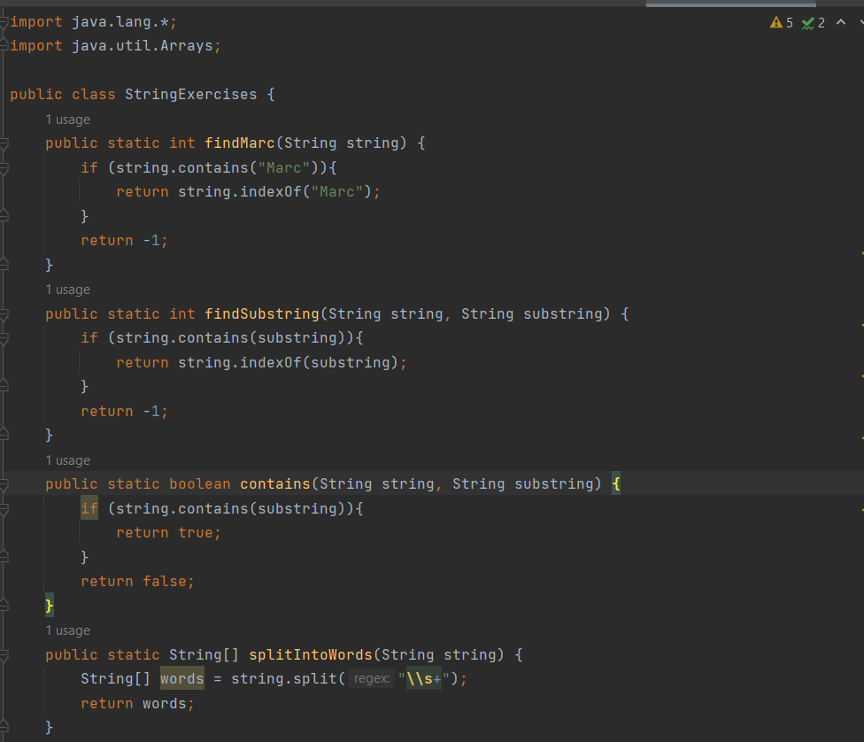

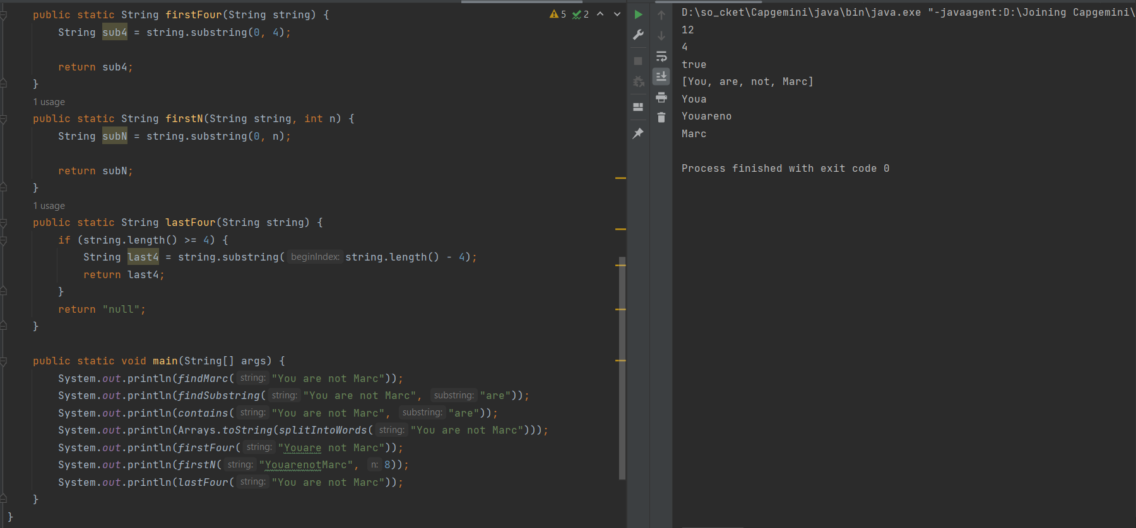

**Q4:** Create a class named as MatchPatternUtil, and you will have to create few methods in this. Follow the below table for method description. For testing the MatchPatternUtil class, create a main class and test functionality with appropriate input.

|  |  |
| --- | --- |
| Class Name | MatchPatternUtil |
| public static int[] matchabSequence(String string){  return null;} | Return the array of int, which holds the index number of matched pattern. string is non-null string input: abaaaba output: 0 4 |
| public static int[] findDigitLocation(String string){  return null;} | Return the array of int, which holds the index number of matched pattern. string is non-null string input: a12c3e456f output: 1 2 4 6 7 8 |
| public static int[] findWhiteSpaces(String string){  return null;} | Return the array of int, which holds the index number of matched pattern. string is non-null string input: a 1 56 _Z output: 1 3 6 |
| public static int[] findPattern(String string){  return null;} | Return the array of int, which holds the index number of matched pattern. string is non-null string input: 12 0x 0x12 0Xf 0Xg output: 6 11 What to do : Find a set of characters in which the first character is a “0”, the second character is either an “x” of an “X”, and the third character is either a digit from “0” to “9”, a letter from “a” to “f” or an upper case letter “A” to “F.” |

**Solution –**

